**TOPIC: GENERATIVE AI MODELS CYBERSECURITY**

# PROBLEM IDENTIFICATION

The integration of Generative AI models, such as ChatGPT and DALL·E, into various sectors has raised new challenges, particularly in cybersecurity. While these models provide powerful capabilities, they also present unique vulnerabilities that can be exploited for malicious purposes.

The core research problem is to explore how Generative AI impacts cybersecurity by amplifying specific threats like phishing, data privacy breaches, and misinformation. The study investigates:

The public’s familiarity and interaction with Generative AI and its perceived cybersecurity threats.

Confidence levels in organizations’ ability to regulate AI and in developers’ commitment to prioritizing cybersecurity in their designs.

Support for stricter regulations to prevent misuse of AI in the context of cybersecurity.

By investigating these questions, the study aims to provide insights into how AI can be better controlled and utilized for cybersecurity purposes while reducing its potential for harm.

# LITERATURE REVIEW

Generative AI models have become integral to modern technological landscapes, enabling creativity and innovation across various sectors. However, these models introduce several vulnerabilities and risks that need to be addressed in the cybersecurity space:

* **Adversarial** **Attacks**: AI models, especially generative ones, can be vulnerable to adversarial attacks where small, imperceptible changes to input data lead to incorrect outputs (Goodfellow et al., 2014). For instance, in cybersecurity, these attacks can be used to bypass security filters, leading to security breaches.
* **Phishing** **and** **Misinformation**: One of the most immediate risks of Generative AI models is the ability to produce convincing phishing messages and deepfakes, which are used to deceive individuals or systems

(Chesney & Citron, 2019). The rapid creation and distribution of false

information can cause severe harm in political, social, and economic contexts.

* **Data** **Privacy**: Generative AI models often rely on vast amounts of training data, which might unintentionally include personal or sensitive information. This raises significant concerns about data privacy and the potential exposure of private information (Carlini et al., 2021).

In the realm of cybersecurity, it is essential to understand how these AI-driven risks could be mitigated and whether current regulatory frameworks are sufficient to protect users and systems from AI-powered cyberattacks (Binns, 2018; Vincent, 2021).

# RESEARCH DESIGN

The research is designed to gather a comprehensive view of public perceptions and concerns regarding Generative AI in cybersecurity. A structured questionnaire is used, combining quantitative and qualitative data to capture respondents' familiarity with the technology, trust in AI developers, concerns about its misuse, and support for regulation. The survey specifically targets:

The level of familiarity with generative AI models and cybersecurity concepts.

Perceptions of cybersecurity threats that are amplified by generative AI.

Confidence in AI regulation and developer accountability in addressing cybersecurity risks.

# DATA COLLECTION

The data collection process involves distributing the survey to a diverse set of respondents, including individuals from various professional backgrounds:

**Sample Size**: 20 respondents with backgrounds ranging from cybersecurity professionals to general users with little or no expertise in AI.

**Data Types**:

* **Quantitative** **data**: Ratings on familiarity with Generative AI, trust in developers, and confidence in regulatory measures (using a 1-5 scale).
* **Qualitative** **data**: Open-ended responses on perceived threats and recommendations for stricter regulations.
* **Data** **Collection** **Tools**: Google Forms or similar platforms were used to design and distribute the survey, allowing easy analysis of responses.

# DATA ANALYSIS

The analysis of the survey responses reveals several trends:

* **Familiarity** **with** **Generative** AI: Approximately 50% of respondents rated themselves as moderately familiar (3/5), with a strong representation (85%) of people who have used generative AI tools like ChatGPT or DALL·E.
* **Threat** **Amplification**: Data privacy breaches (55%) and misinformation (30%) are considered the most likely threats to be amplified by Generative AI models. Interestingly, phishing was rated much lower (10%).
* **Confidence** **in** **Regulation**: The majority (75%) expressed moderate confidence in organizational ability to regulate AI technologies to prevent misuse, with only 5% extremely confident.
* **Trust** **in** **Developers**: 60% of participants rated their trust in AI developers to prioritize cybersecurity as moderate (3/5), indicating concerns but a general trust in developers to act responsibly.

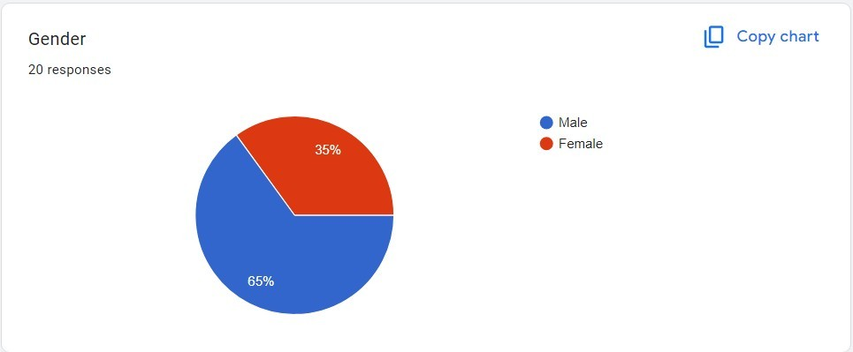

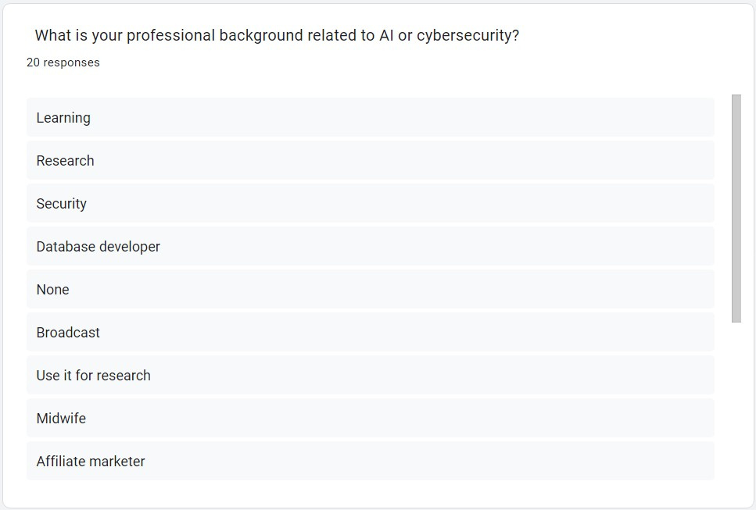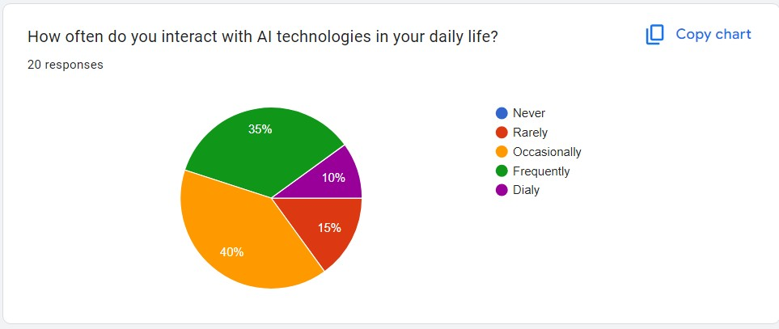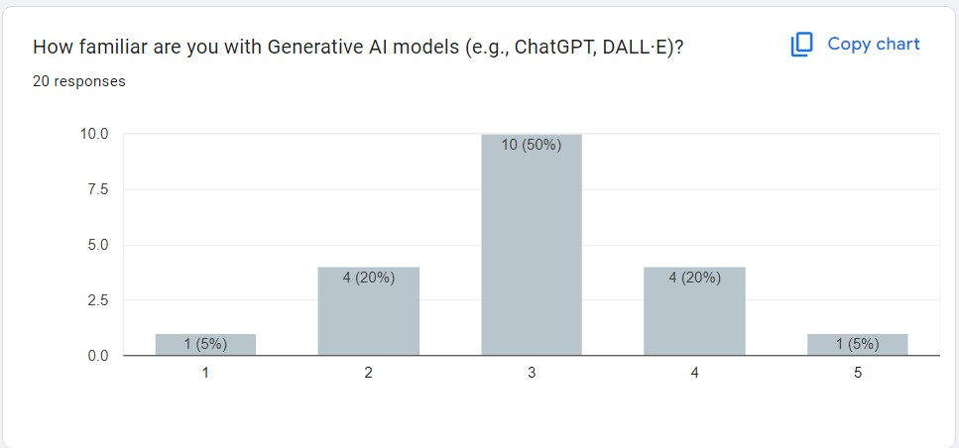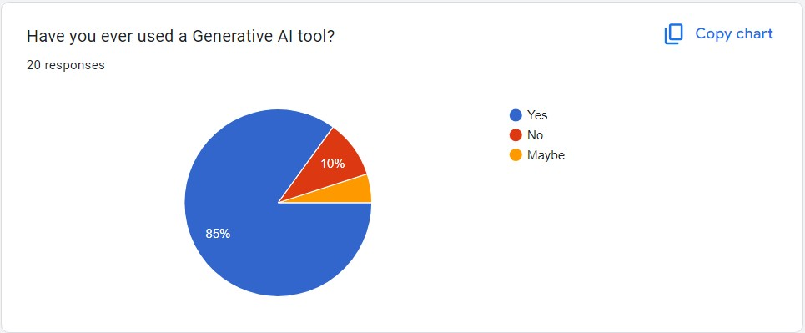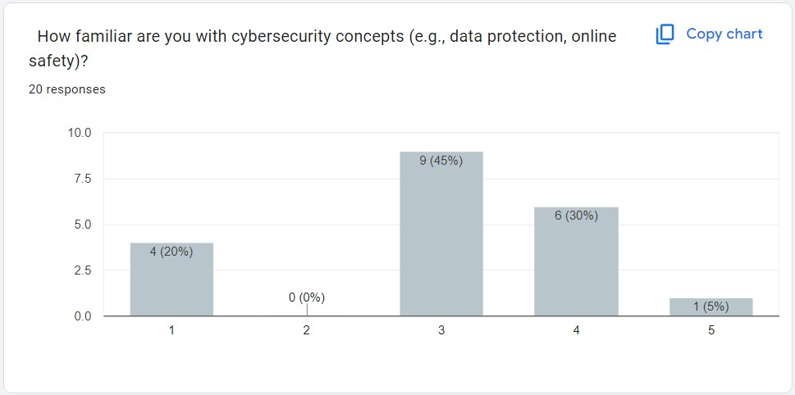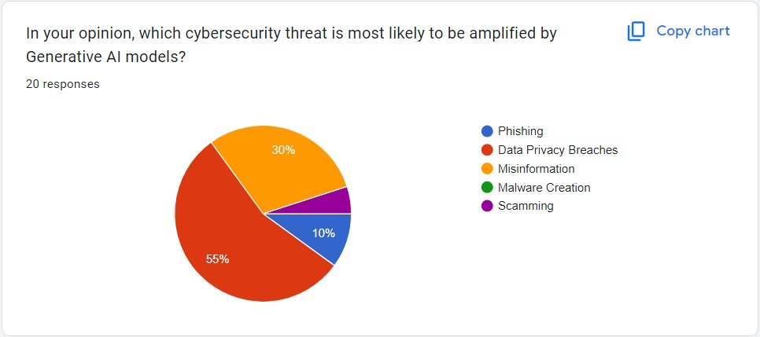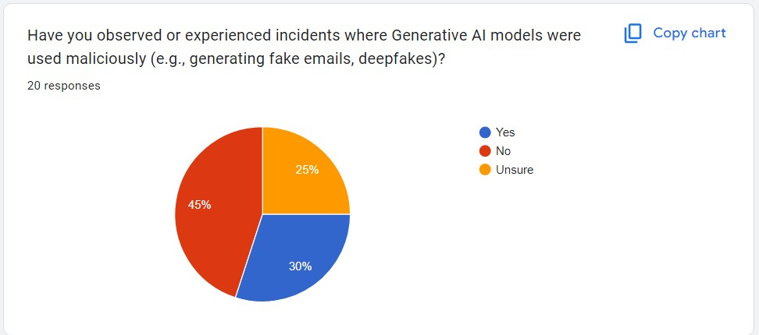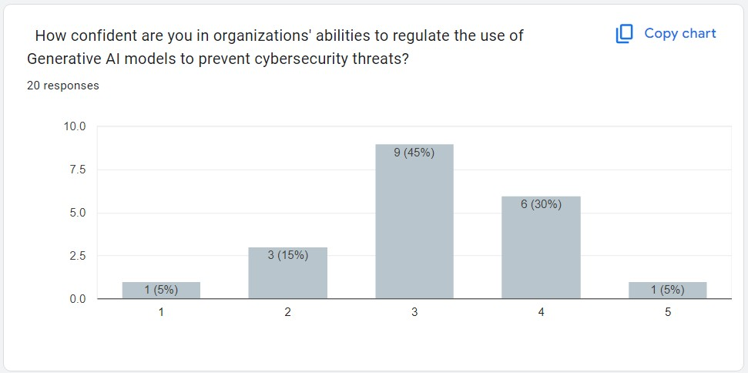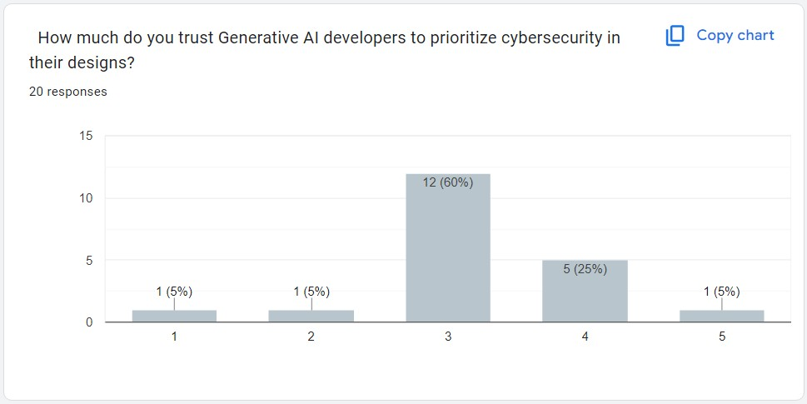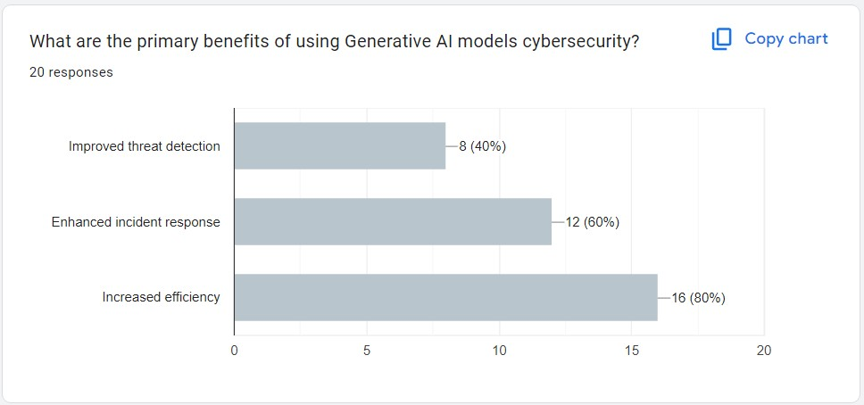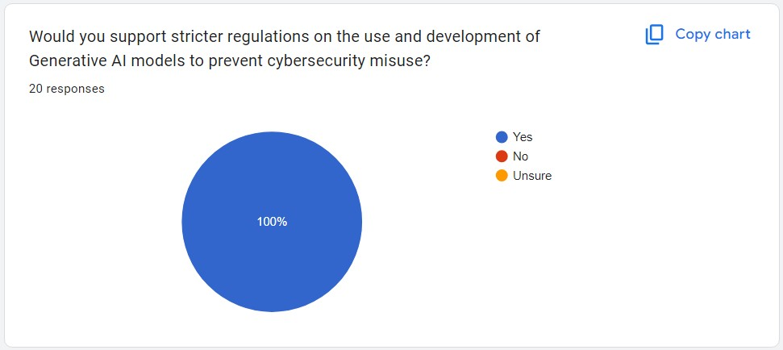

# RESULTS

The survey results suggest several key takeaways:

* **Generative** **AI** **Usage**: The widespread adoption of AI tools like ChatGPT and DALL·E is reflected in the high frequency of use, indicating growing integration of AI into daily workflows across different industries.
* **Cybersecurity** **Threats**: There is a clear recognition that data privacy and misinformation are the most pressing risks associated with generative models, a finding that is consistent with broader concerns in the literature (Chesney & Citron, 2019).
* **Regulatory** **Confidence**: While the majority of respondents express moderate confidence in regulation, the overall sentiment indicates that stricter regulations are needed to address AI’s misuse in cybersecurity.
* **Trust in Developers**: Trust in AI developers is moderately positive, suggesting that most respondents believe developers will take action but expect more transparency and accountability.

# DISCUSSION

* Implications for Security: The findings reinforce the need for greater education and awareness about the risks of AI in cybersecurity. Although Generative AI models offer significant security benefits, such as improved threat detection and incident response, they also increase the potential for malicious exploitation.
* Connection to Literature: The results align with concerns raised by experts about the ethical implications of AI misuse and the security vulnerabilities inherent in these models (Chesney & Citron, 2019; Carlini et al., 2021). Public trust in developers and regulators remains moderate, indicating that stakeholders are aware of the risks but may lack confidence in current oversight measures.

# CONCLUSION

This survey highlights the dual nature of Generative AI in cybersecurity:

* **Benefits**: AI models can enhance efficiency, threat detection, and incident response.
* **Risks**: However, they also amplify threats like privacy breaches and misinformation. Given the relatively moderate confidence in AI regulation and the need for stricter oversight, further action is necessary to ensure these technologies are used responsibly and securely.

# RECOMMENDATIONS

1. **For**  **Developers**:

Focus on adversarial robustness and secure model design to prevent vulnerabilities (Goodfellow et al., 2014).

Increase transparency about how data is handled and how models are trained.

1. **For**  **Policymakers**:

Establish international standards for ethical AI deployment, ensuring accountability (Vincent, 2021).

Create regulations that address emerging threats from AI-generated content and models.

1. **For**  **Organizations**:

Implement AI-powered security systems that can detect AI-generated threats.

Educate employees and users on recognizing AI-generated phishing or deepfake content.

# LIMITATIONS

* Sample Size: The small sample size (20 participants) may not represent the broader public’s views, particularly across different industries.
* Representation: While respondents come from diverse backgrounds, the sample may not fully reflect opinions from all sectors impacted by Generative AI.
* Rapid Technological Evolution: AI and cybersecurity are evolving rapidly, which means findings could quickly become outdated.

# REFERENCES

* *Goodfellow, I., Shlens, J., & Szegedy, C. (2014). Explaining and Harnessing Adversarial Examples. ArXiv.*
* *Chesney, R., & Citron, D. (2019). Deepfakes: A Looming Challenge for Privacy, Democracy, and National Security. SSRN.*
* *Carlini, N., et al. (2021). Extracting Training Data from Large Language Models. ArXiv.*
* *Binns, R. (2018). Fairness in Machine Learning: Lessons from Political Philosophy. FAT* Proceedings.*
* *Vincent, J. (2021). The Ethics and Risks of AI-Generated Content. The Verge.*